Software Specification Document
Project ID/No./Code |  | BTScannerFWUpdateSDK Programmer Guide  For Android User
Ref Document No.
Written by |  | Yifan Wang
Project Name |  | BTScannerFWUpdateSDK
Approved by |  | Client |  | Contact Window
Version | Creation Date | Prepared by | Summary of Changes
1.0 | 2015/05/05 | Yifan | Create

TABLE OF CONTENTS
1. Introduction 2
2. BTScannerFWUpdateSDK Overview/Architecture 3
2.1 Class diagram 3
2.2 Class Description 4
2.3 Sequence diagram 5
2.4 Sequence diagram description 5
3. BTScannerFWUpdateSDK -API List 6

Introduction
BTScannerFWUpdateSDK is a Development Kit designed for CipherLab cordless scanners to update firmware by device`s Bluetooth for the Android Mobile.

Note : The mobile platform must be Android 4.x (or plus)

BTScannerFWUpdateSDK Overview/Architecture

Class diagram
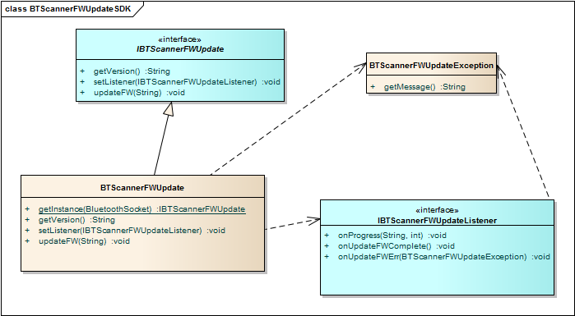

Class Description
Class Name | File | Description
IBTScannerFWUpdate | btscannerfwupdatesdk.jar | The functions to update firmware
IBTScannerFWUpdateListener | btscannerfwupdatesdk.jar | To listen to BTScannerFWUpdate
BTScannerFWUpdate | btscannerfwupdatesdk.jar | To Implement IBTScannerFWUpdate
BTScannerFWUpdateException |  | To throw exception from listener.

Sequence diagram
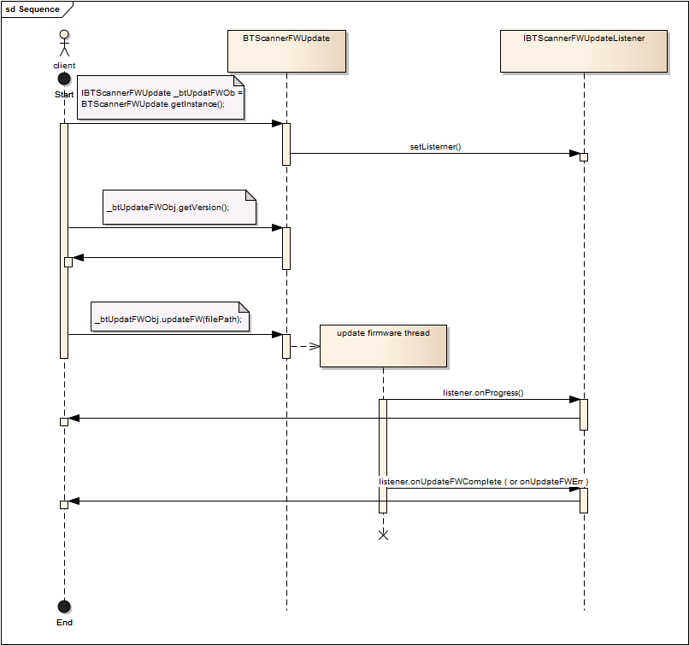

Sequence diagram description

Name | Description
Client | Client end to use SDK.
BTScannerFWUpdate | The instance generating from SDK is used to get firmware version and update firmware.
IBTScannerFWUpdateListener | Listener to report updating firmware progress and status.

BTScannerFWUpdateSDK -API List
Name | Note
BTScannerFWUpdate
getInstance | Get the instance of IBTScannerFWUpdate.  BluetoothSocket btSocket = CreateSocket();  IBTScannerFWUpdate _btFWUpdtObj = BTScannerFWUpdate.getInstance(btSocket);
setListener | Set listener to listen updating firmware status.  IBTScannerFWUpdateListener mUpdateFWListener = new IBTScannerFWUpdateListener(){…}  try{  _btFWUpdtObj.setListener(mUpdateFWListener);  }  catch(NullPointerException e){  System.out.println(e);  }
updateFW | The function is to update firmware, it update firmware from worker thread and  callback by IBTScannerFWUpdateListener to report status.  String fileName = "/storage/sdcard1/xxx.SHX";  try{  _btFWUpdtObj.updateFW(fileName);  }  catch(BTScannerFWUpdateException e){  System.out.println(e);  }
getVersion | The function is to get firmware version.  try{  _btFWUpdtObj.getVersion ();  }  catch(BTScannerFWUpdateException e){  System.out.println(e);  }
IBTScannerFWUpdateListener
onProgress | The function is to report updating progress.
onUpdateFWErr | The function is to report updating firmware error.
onUpdateFWComplete | The function to report update firmware complete.

